**Group**

* Small number of people who participate for social or work purposes
  + Share an interest in the same things or share a common purpose
  + Participate in planning and decision making
  + Feel connected to the other members

**C:\Users\pantherl\AppData\Local\Microsoft\Windows\Temporary Internet Files\Content.IE5\BRCK1VAD\MC900297565[1].wmf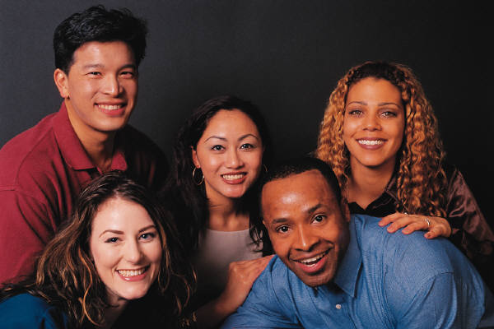C:\Users\pantherl\AppData\Local\Microsoft\Windows\Temporary Internet Files\Content.IE5\BRCK1VAD\MC900071009[1].wmf**

**Group Life Cycle**

(1) Forming

* Getting to know the group members
* Find a leader
* Polite, avoid disagreements, find similarities
* Sounds like:
  + “What are we supposed to do?”
  + “Why am I in this group?”
  + “Shouldn’t we get more information, or a leader?”

(2) Storming

* Members are more comfortable in the group
* Difference begin to surface and members start to assert their individual positions
* Uncomfortable period where people often disagree and wonder if the problem can be solved
* Sounds like:
  + “This is a waste of time”
  + “We’re just going around in circles”
  + “Some people talk too much, and others just sit there”

(3) Norming

* Members begin to function effectively together and to develop a sense of group identity
* Group norms (expectations) are established
* Sense of rules and limits are in place
* Group roles are established
* Sounds like:
  + “”If you look for more historical information, I’ll do two interviews”
  + “Who did we agree would write the note cards?”
  + “Let’s make sure anyone with any objections gets a turn to talk”

(4) Performing

* Energy is focused on the problem being solved, group tasks, and finding solutions
* Group members can predict each others’ responses and know how to avoid certain pitfalls
* Sounds like:
  + “So we all agree to the solution?”
  + “What’s the best way to report on our conclusion?”
  + “Are we ready to write this?”